**Challenge 1.0: Hello, Shodan**

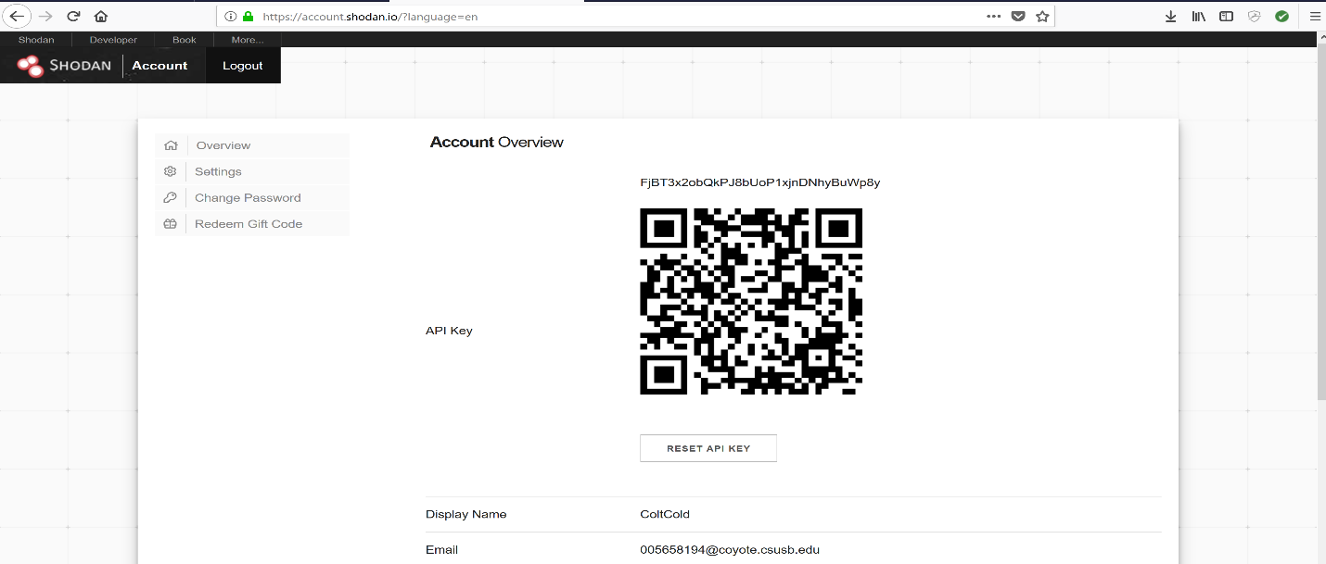

* Account created on Shodan with API key shown above.

**Challenge 1.1: Webcams**

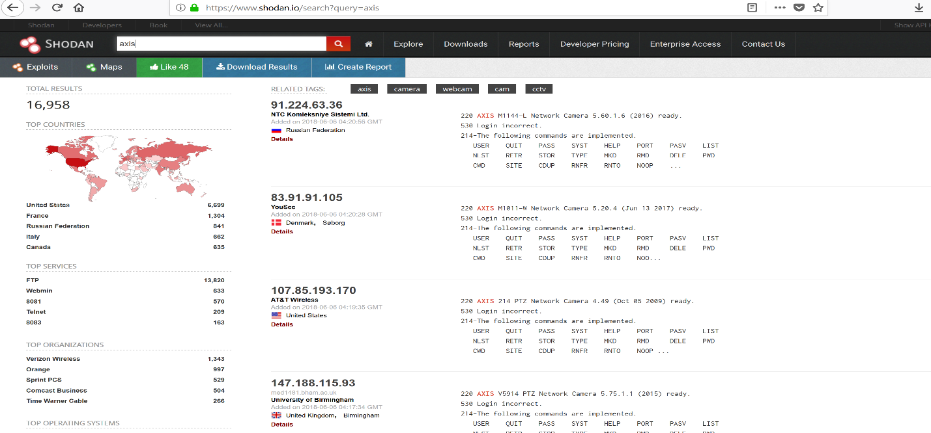

* The following steps will give you the following answer, and give you information as shown above.

**Challenge 1.2: Filtering**

* Country: US

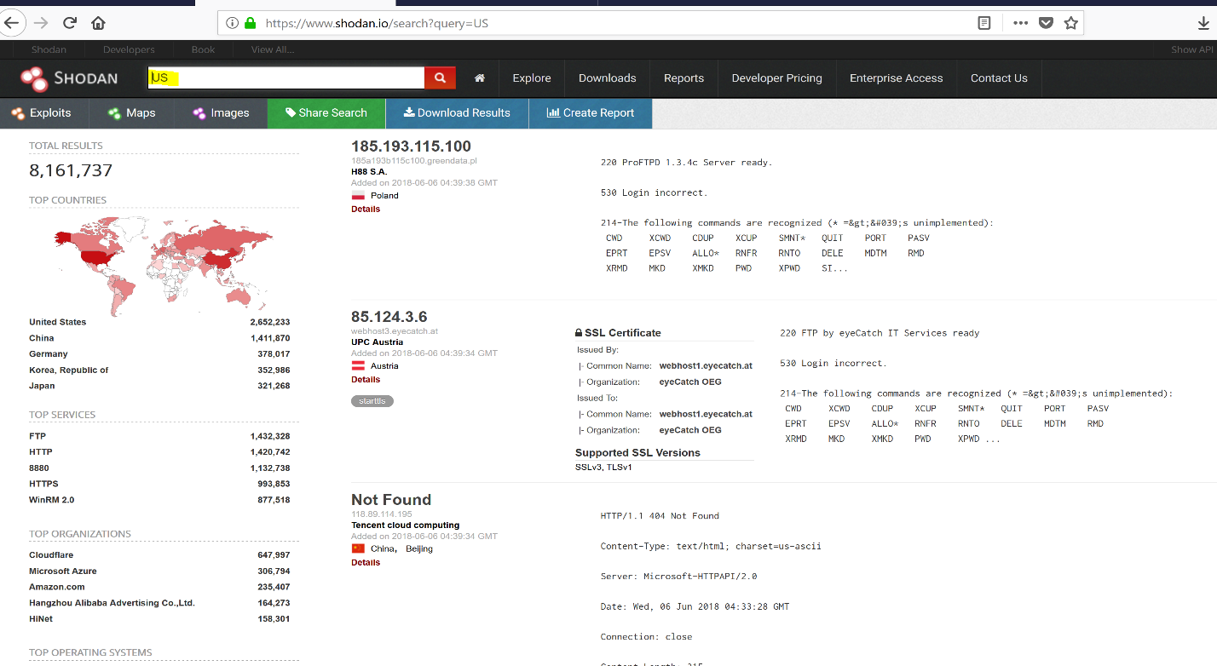

* City: “San Francisco"

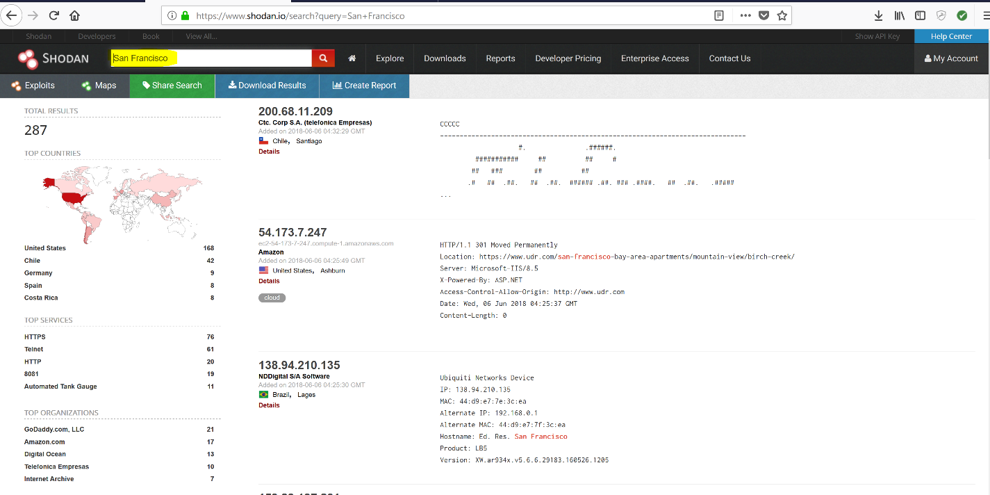

* Hostname: google

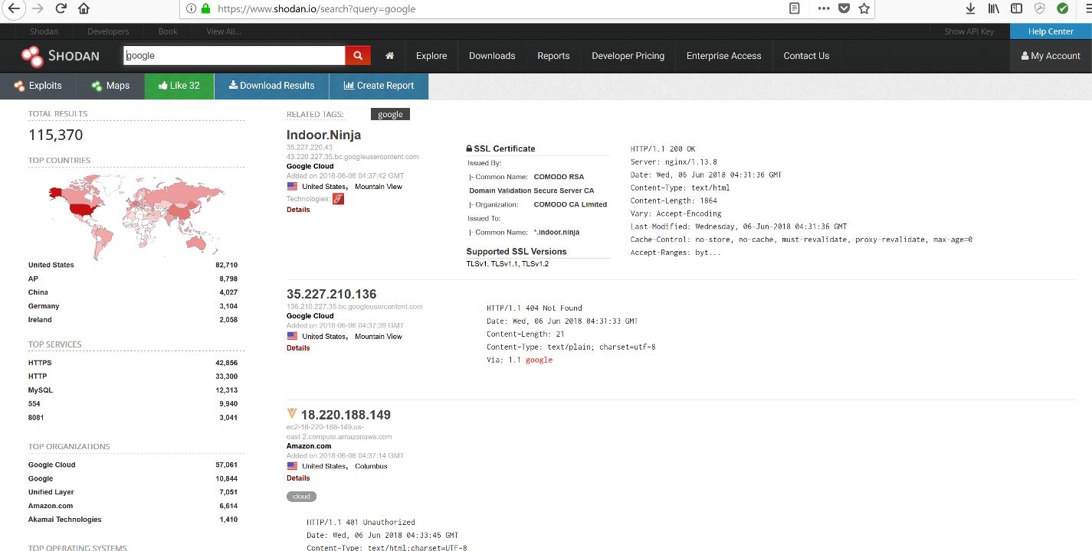

* apache city: “San Francisco"

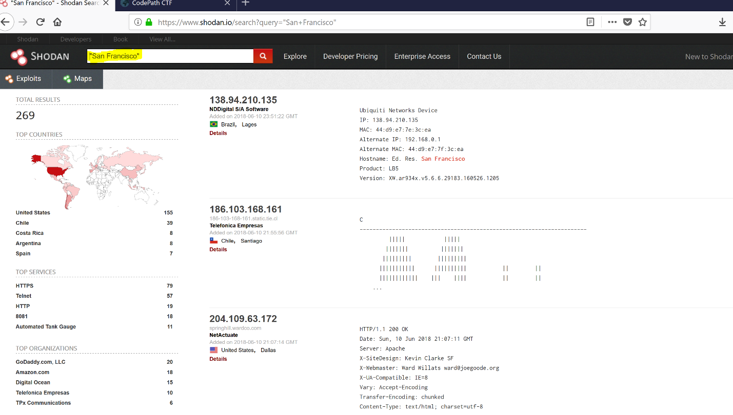

* Ran Metasploit to find web cam for the zoo.

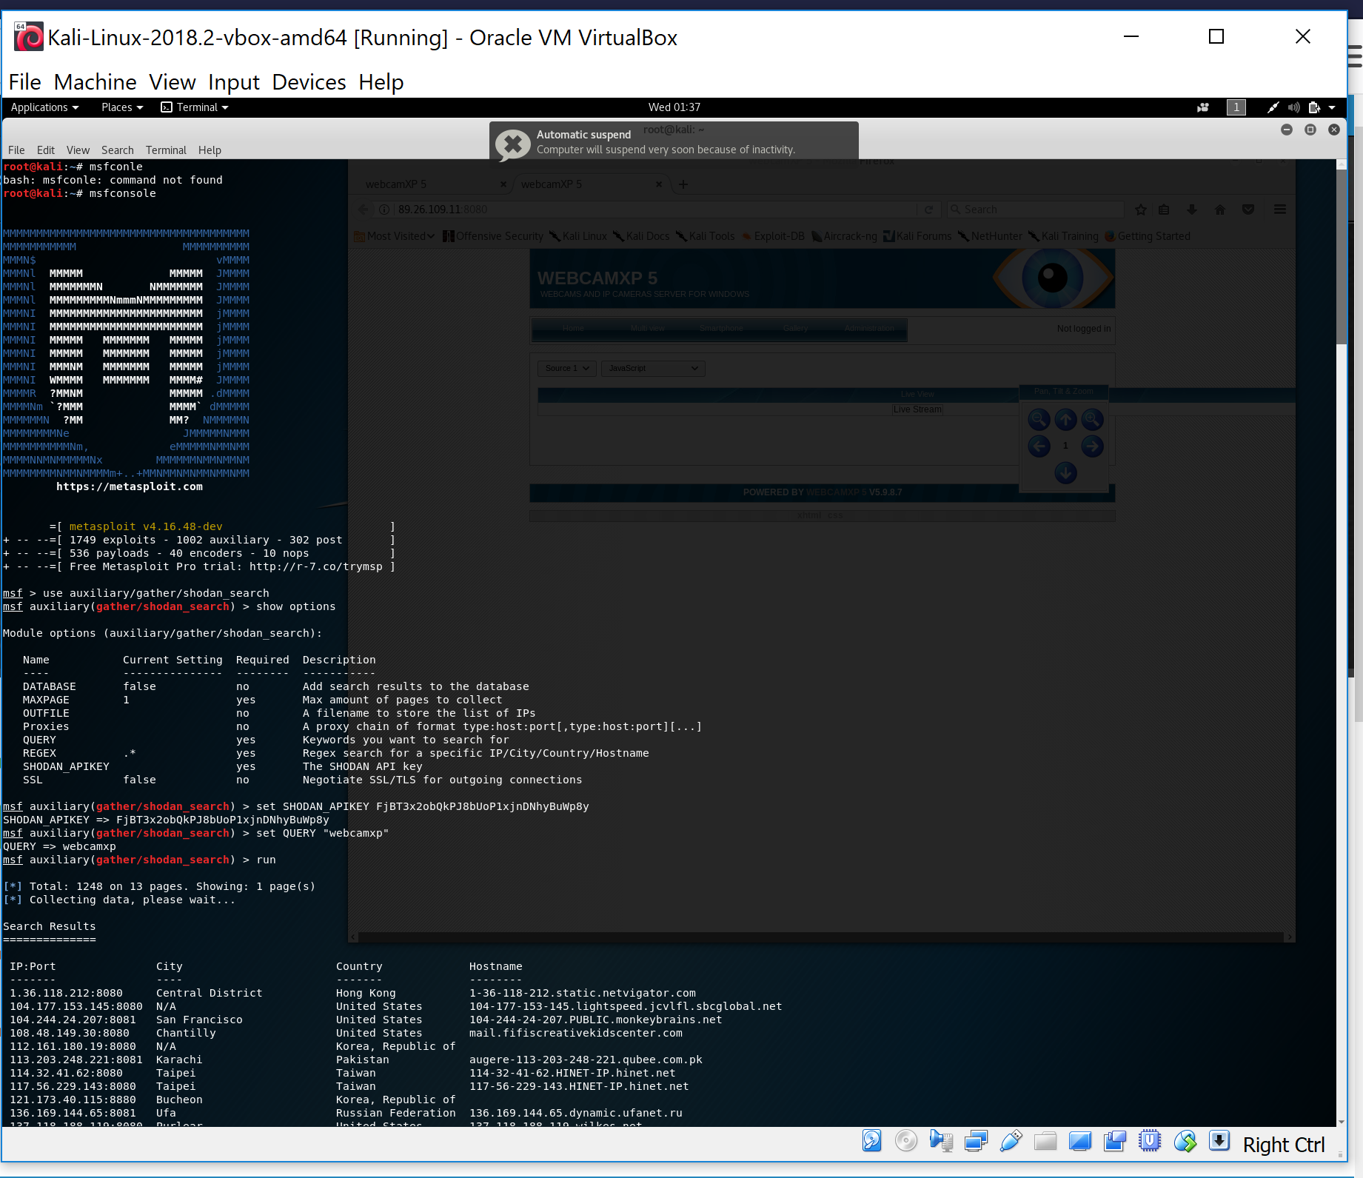

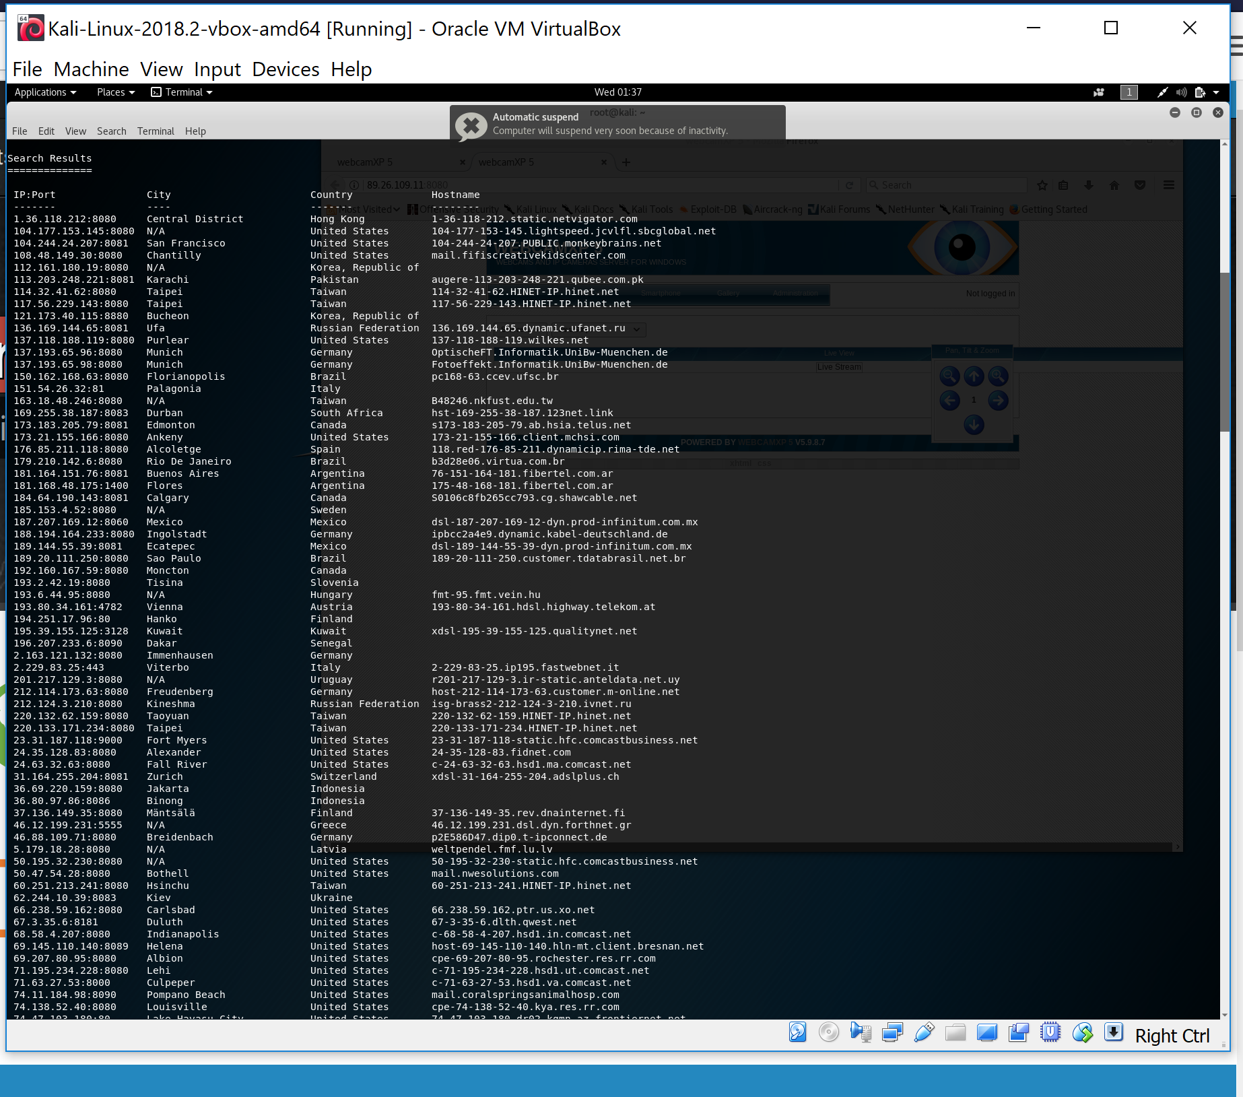

* Unable to find to zoo web cam, cam or link had to be taken down.

**Challenge 2.0: Tool Up**

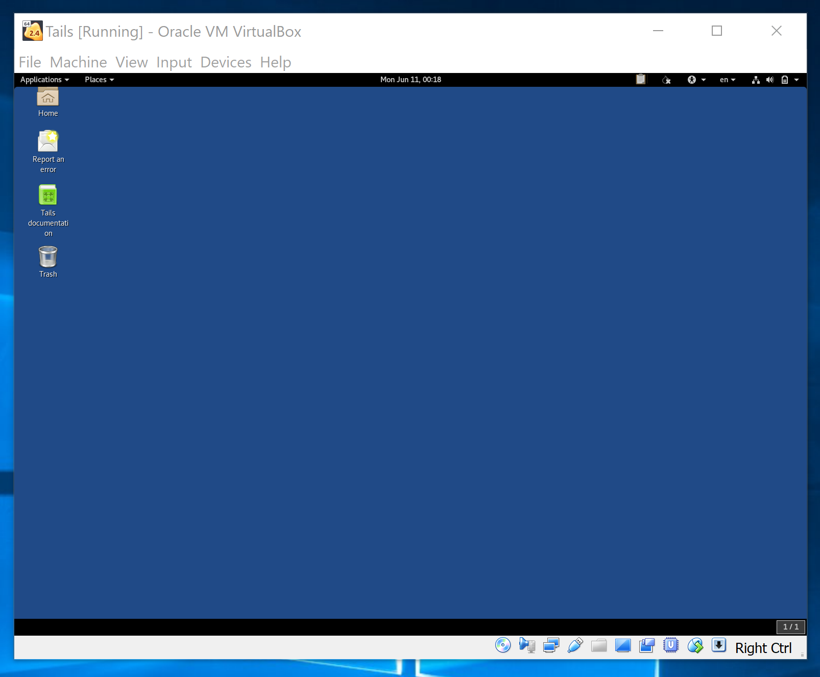

* After following the steps your new VM is completed and ready for use.

### Challenge 2.1: Switching Circuits

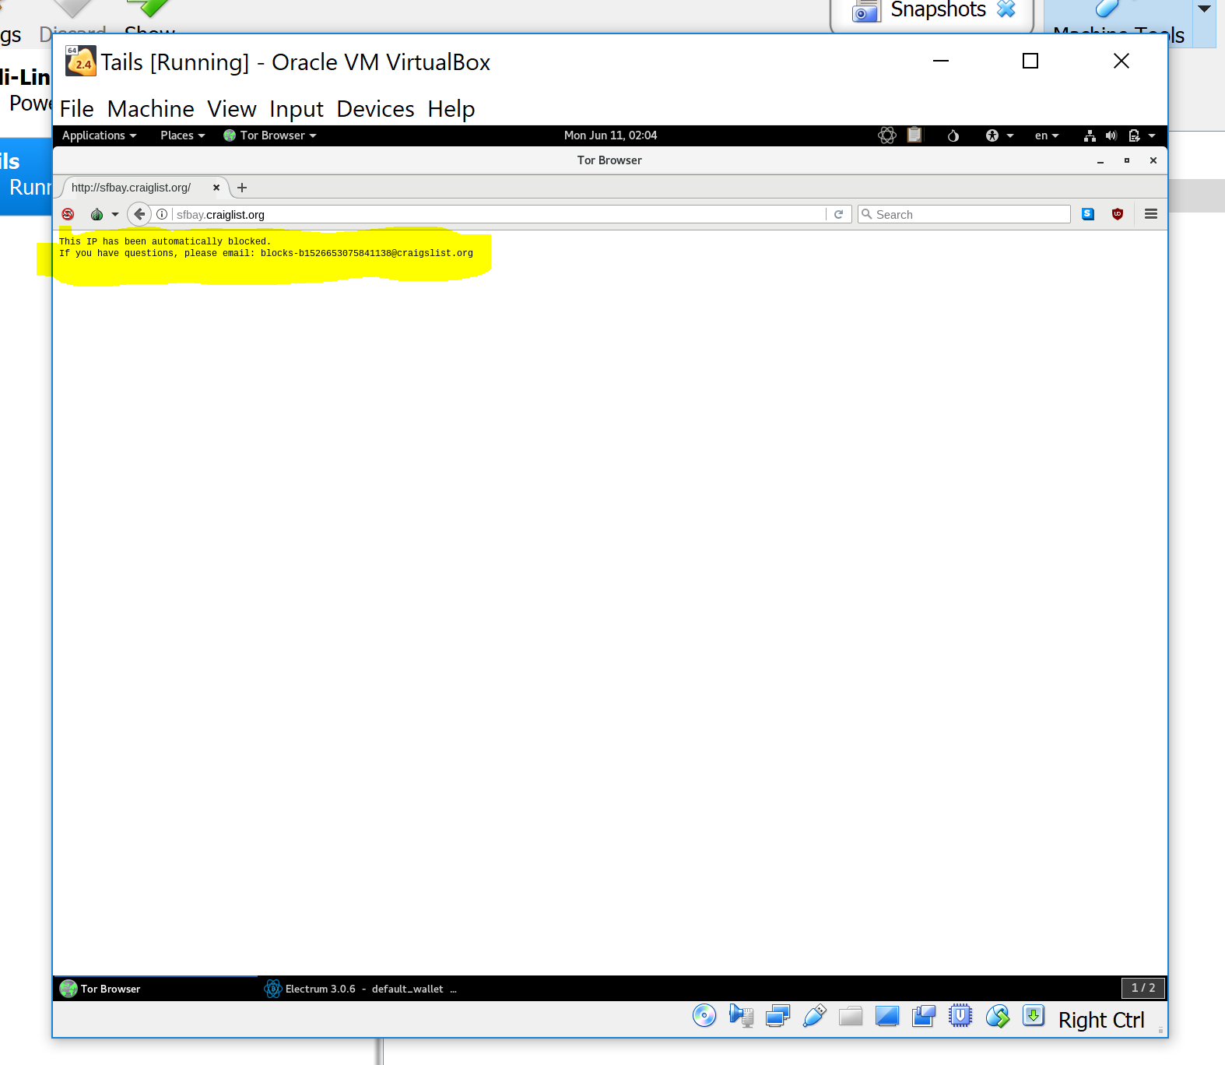

* Unable to connect to the circuits on the Tor Browser <https://sfbay.craigslist.org>

**Challenge 2.2: Onions**

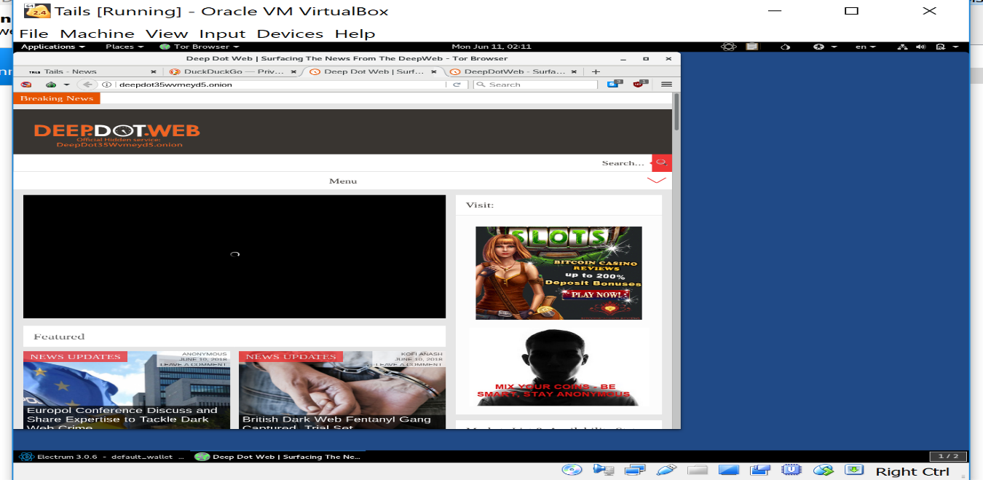

* DeepDotWeb: <http://deepdot35wvmeyd5.onion/>

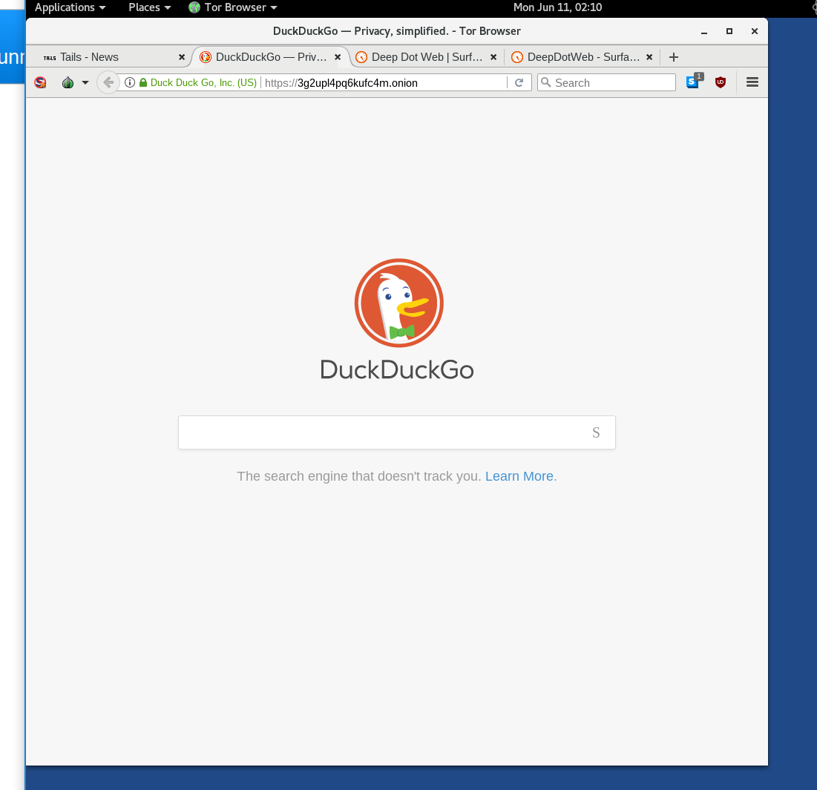

* DuckDuckGo: <http://3g2upl4pq6kufc4m.onion>

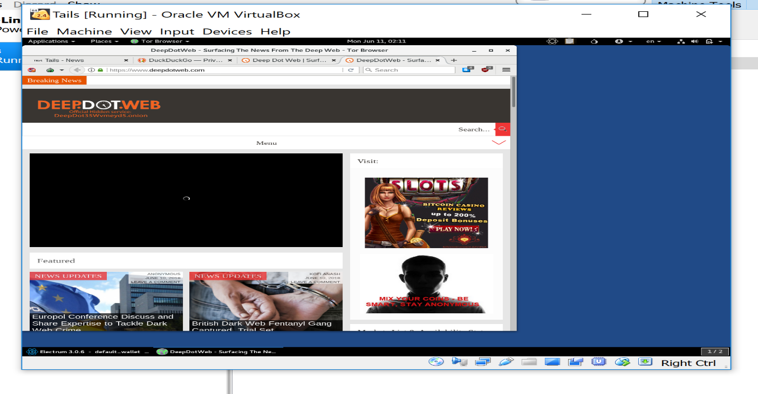

* DeepDotWeb <https://www.deepdotweb.com/>

### Challenge 2.3: Into the Darkness

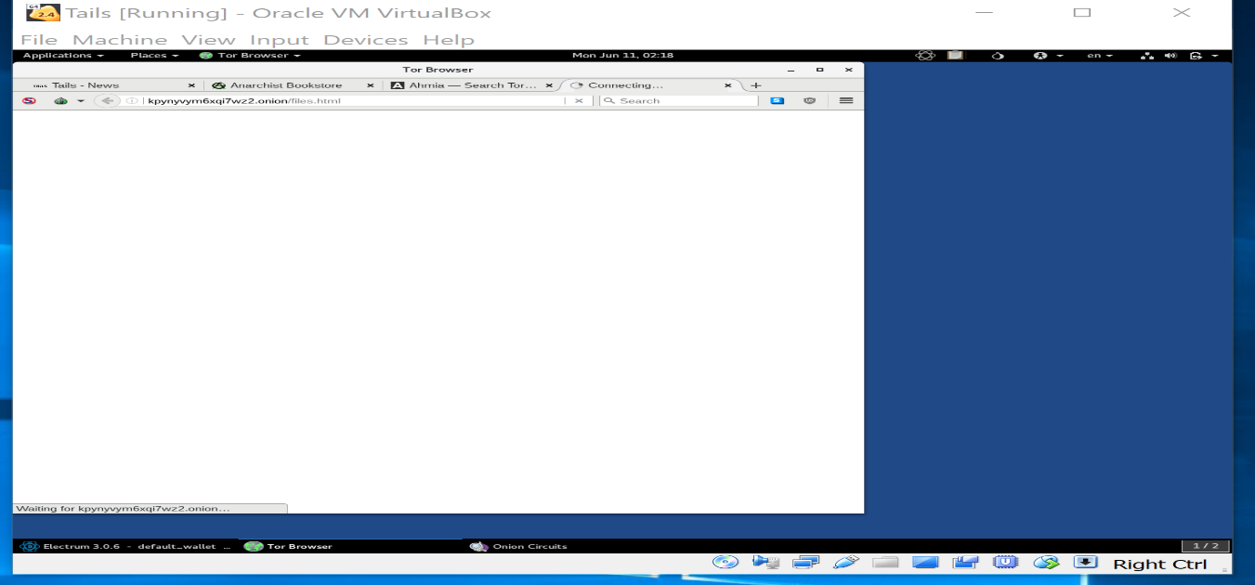

* The Hidden Wiki: <http://wikitorzsjg7mrpw.onion/> Unable to access the hidden wiki with link.

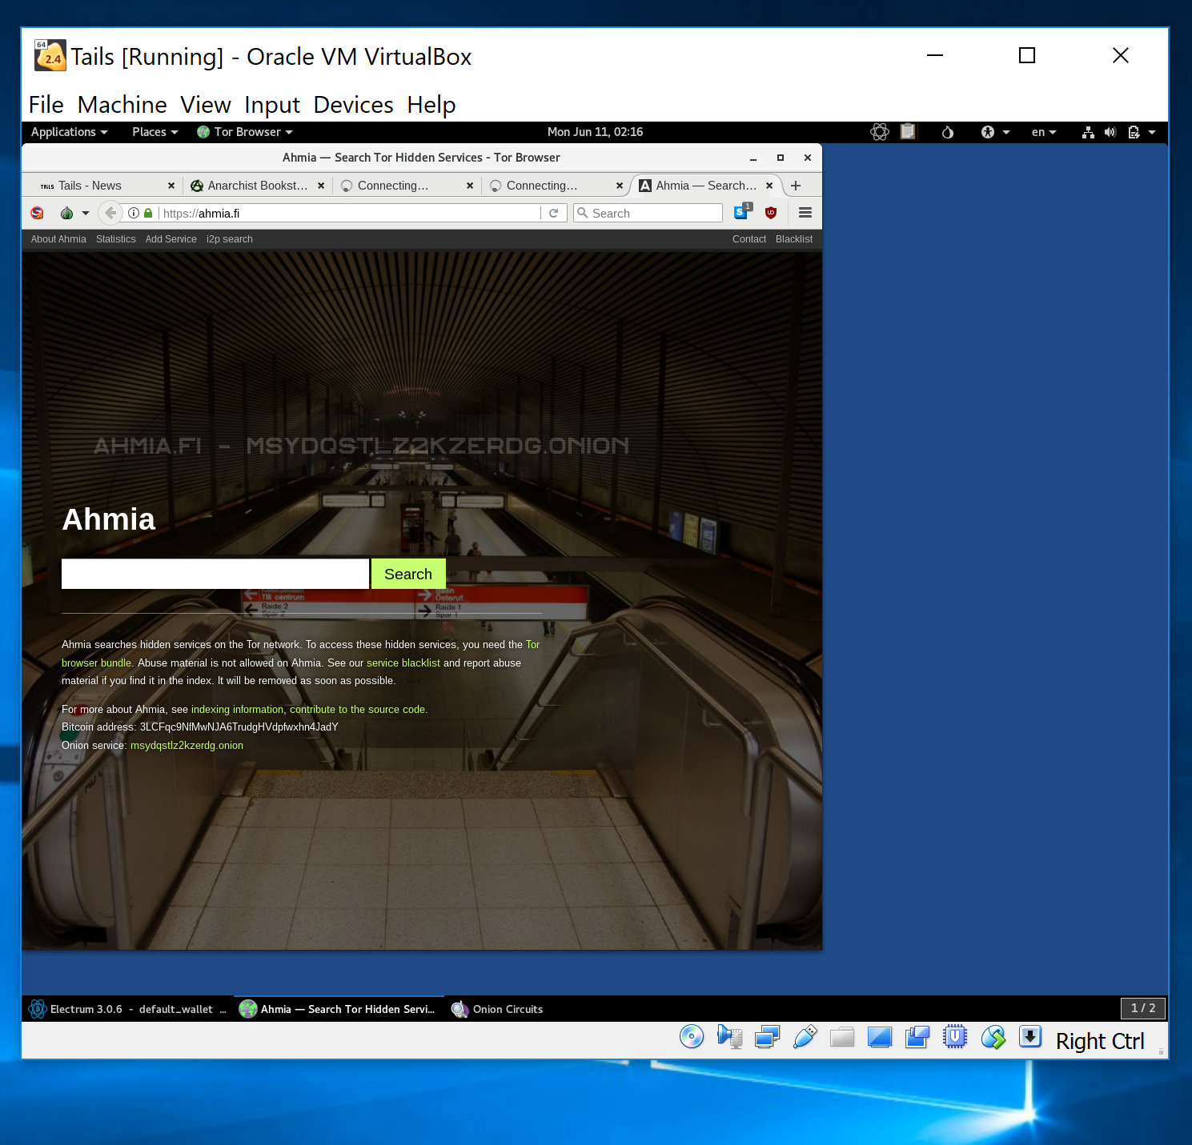

* <https://ahmia.fi/> is a hidden engine with Tor.
* ParaZite - forbidden files: <http://kpynyvym6xqi7wz2.onion/files.html> page was able to load in Tor Brower.

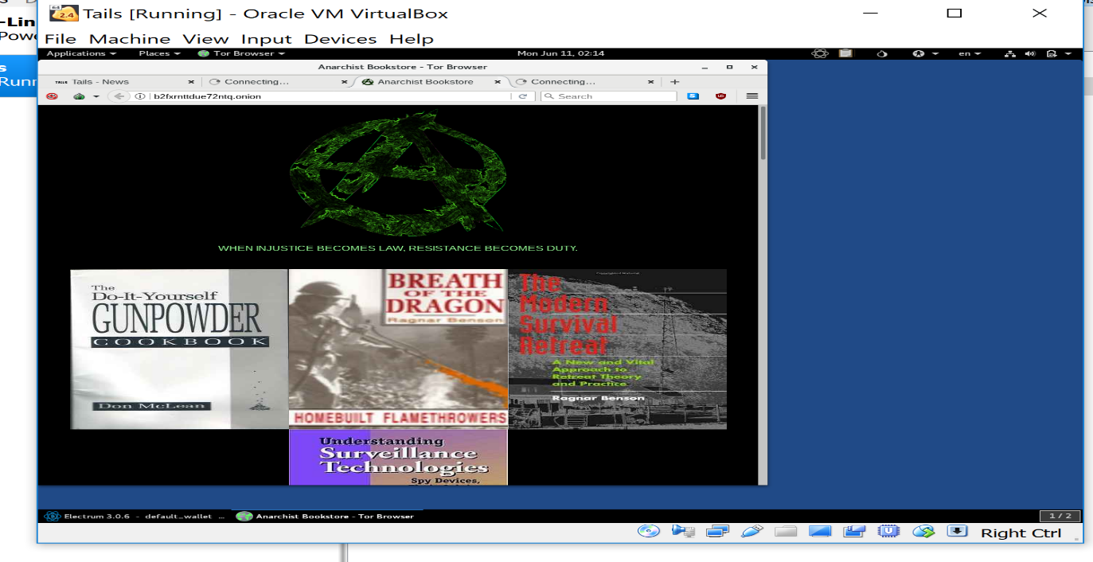

* Anarchist Bookstore: <http://b2fxrnttdue72ntq.onion/> online book store on the Tor bowers.

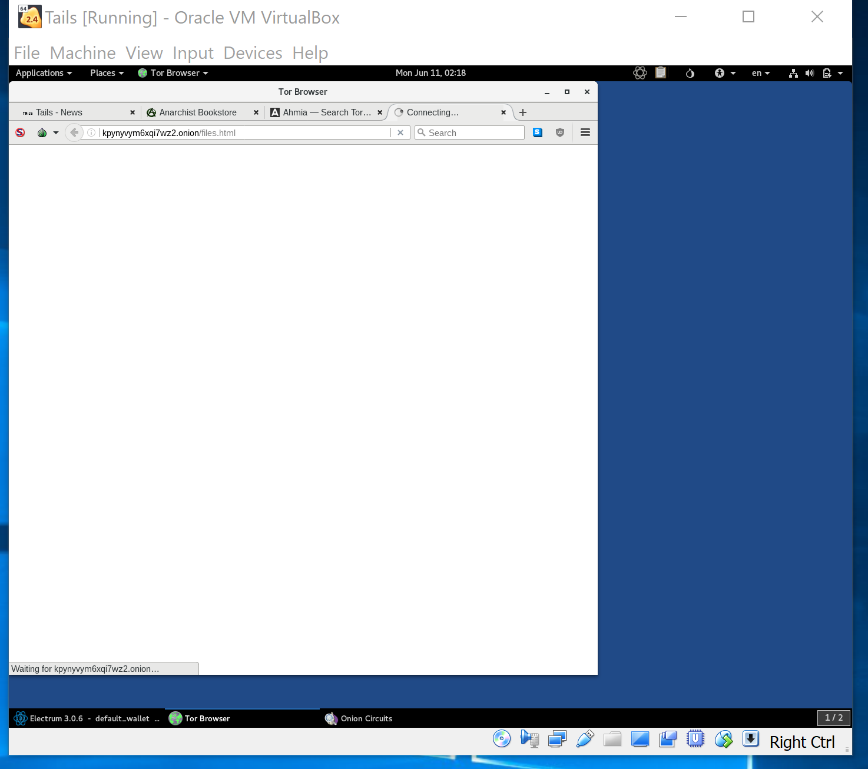

* Onion Crate: <http://7cbqhjnlkivmigxf.onion/> the page was loading, but wouldn’t connect in Tor Bowers.

**Challenge 2.4: How (Not) To Get Busted**

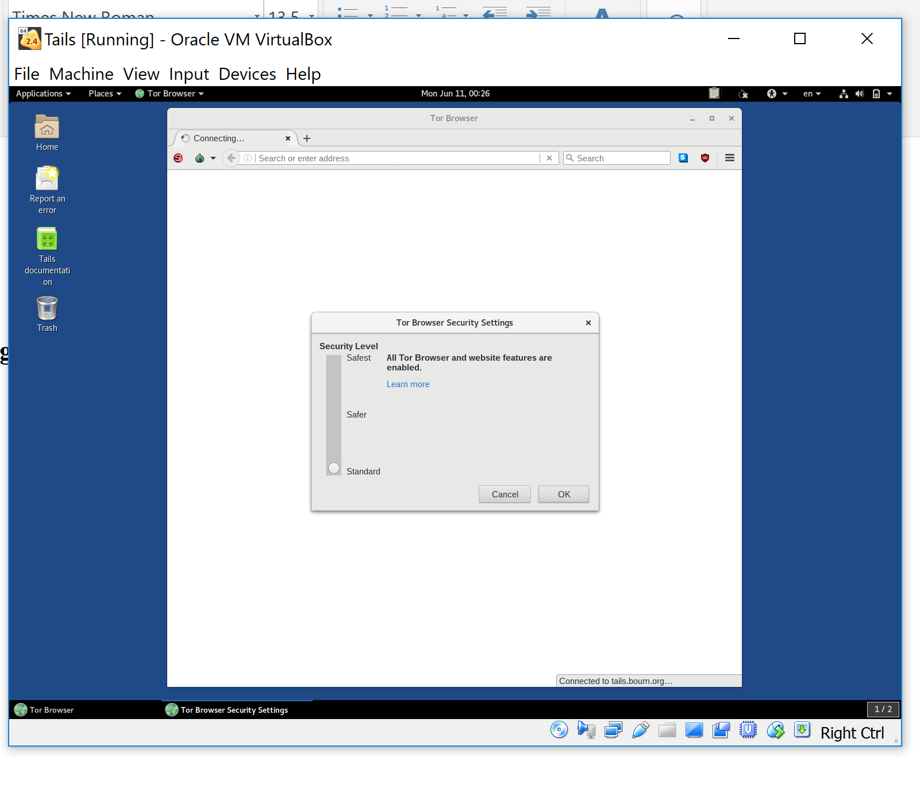

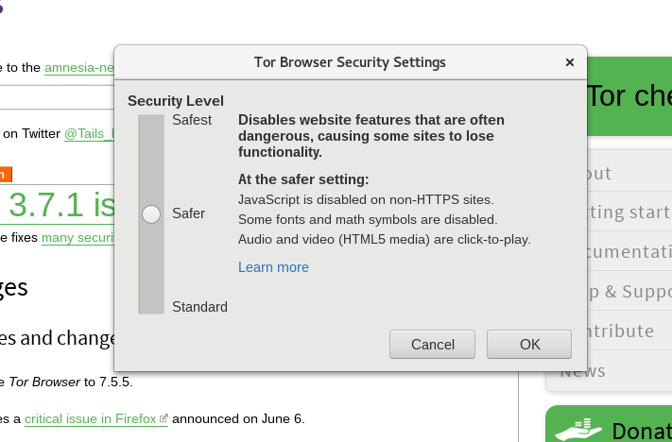

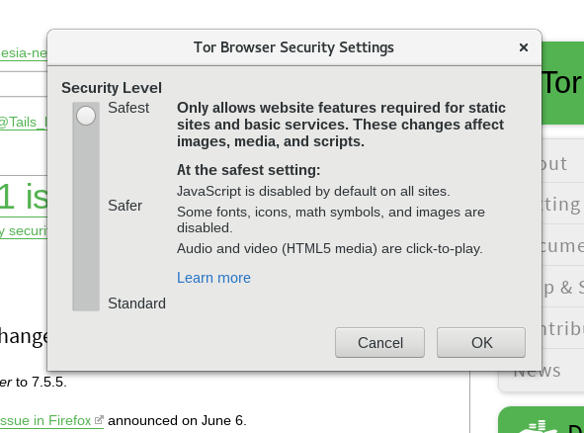

* Each level of security represents the ability to be more secure and hide your IP address as your browser on Tor.

**Challenge 2.5: Then Came the Money**

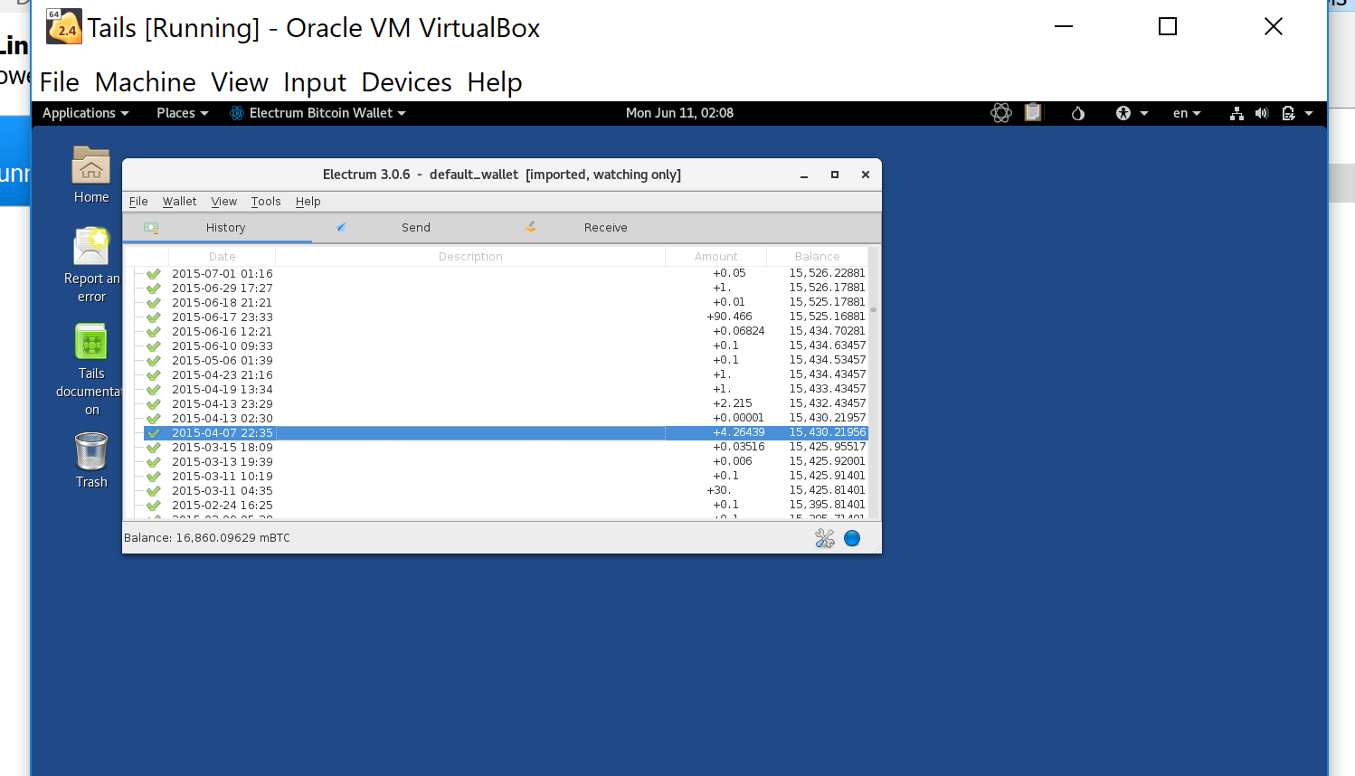

* 1A1zP1eP5QGefi2DMPTfTL5SLmv7DivfNa has a balance of $ 16,860.09629

**Challenge 2.6: Stay in School, Kids**

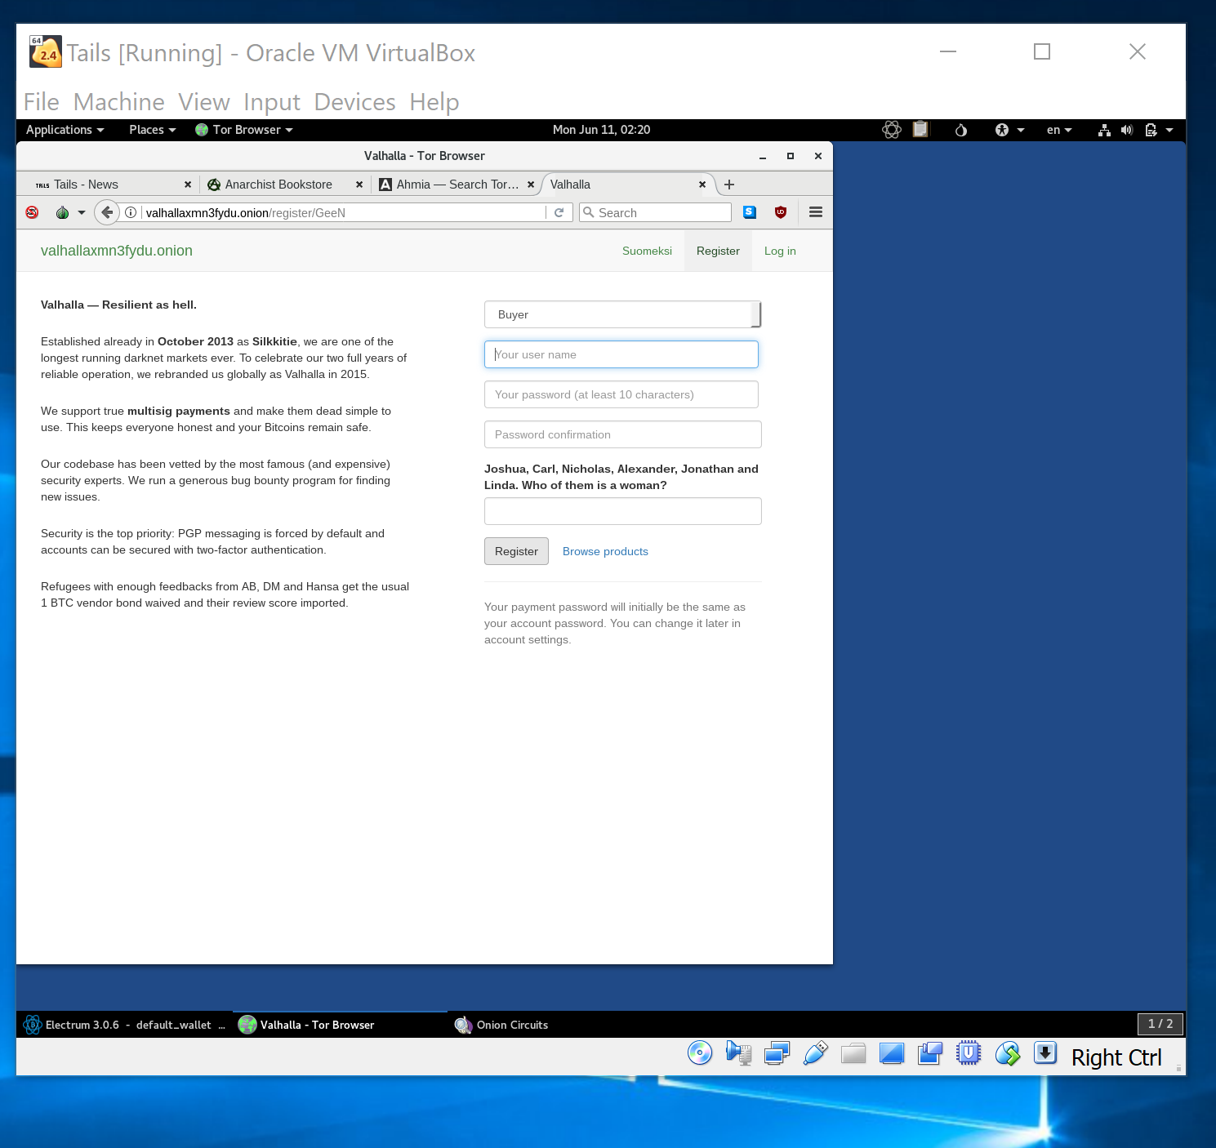

* Market Link: <http://valhallaxmn3fydu.onion/register/GeeN>